Design formula:

1. Data definitions
   1. Variable name is a anything
      1. X is a anything
   2. Enumeration:

; A X is one of:

; - A

; - B

; - C

* 1. Structure (struct)

; A X is (make-something anything anything)

; (define-struct something [y z])

1. Signature, purpose, header
   1. Signature
      1. Function-name : in -> out
   2. 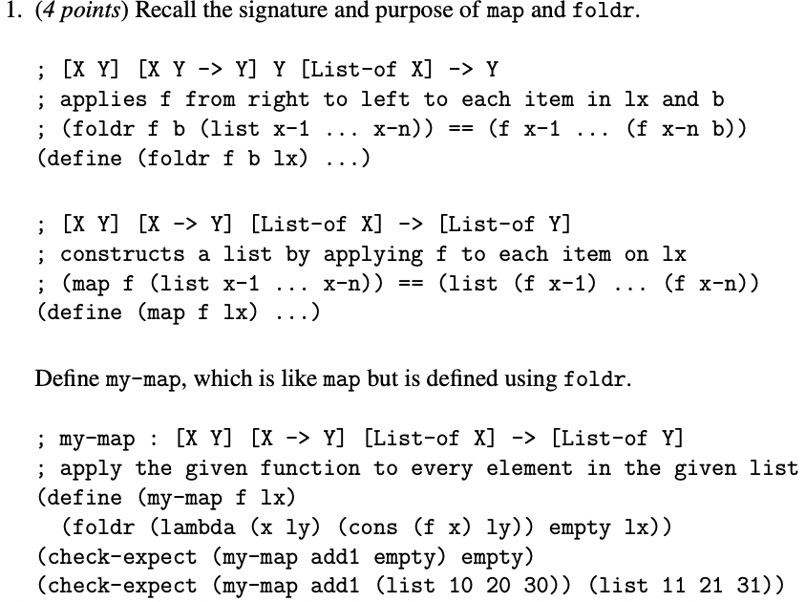Purpose
      1. Quick description of the function
   3. Header
      1. (define (function-name x y z) …)
2. Function examples
   1. (check-expect (function-name x y z) expected-result)
   2. (check-whithin (function-name x y z) expected-result variation)
3. Function template
   1. You don’t need a condition(cond) for structs only enumerations
4. Function definition
   1. Write the function based on template

Big-Bang : world -> image

[on-tick tick-expr rate]

[on-click click-expr]

[on-key key-expr]

[to-draw draw-expr]

Animate : number -> image

Gives an expression a number every tick

A tick happens 28 times a second

a key event is a